What is Driving Data Deluge

What is Driving Data Deluge? Explain with one example.

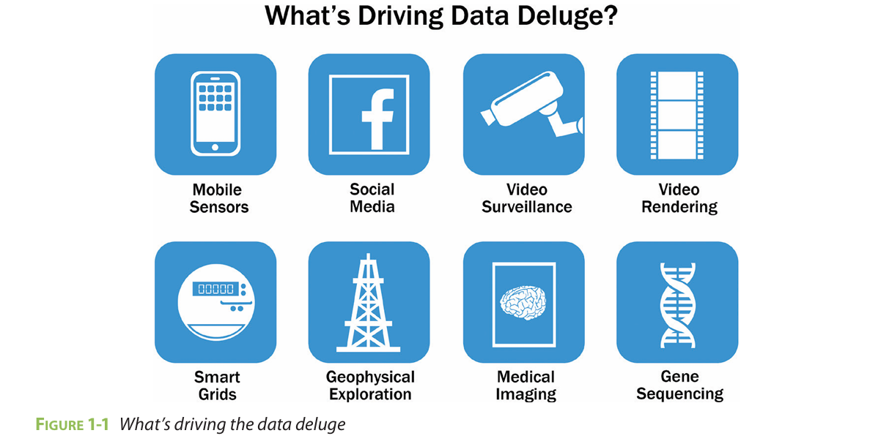

The data deluge refers to the unprecedented surge in data creation, storage, and consumption due to technological, social, and economic factors.

In other words, A data deluge is a scenario where more data is generated than can be successfully and efficiently managed or capped. This results in missed chances to analyze and interpret data to make informed decisions

Below are the key drivers, followed by an example:

1. **Increase in IoT and Connected Devices**

Billions of Internet of Things (IoT) devices (e.g., smartwatches, industrial sensors, home appliances) generate continuous data streams. For instance, a smart city uses IoT sensors to monitor traffic, energy use, and pollution, producing terabytes of data daily.

2. **Advancements in Data Collection Technologies**

High-resolution sensors, 4K/8K cameras, more granular data. For example, modern healthcare systems use MRI machines and wearable health monitors to collect detailed patient data round-the-clock.

3. **Explosion of User-Generated Content**

Social media (e.g., TikTok, Instagram), streaming platforms (e.g., Netflix, YouTube), and online gaming produce vast multimedia data. Over 500 hours of video are uploaded to YouTube every minute, contributing to the deluge.

4. **Affordable Storage and Cloud Computing**

Cheaper storage solutions (e.g., SSDs, cloud services like AWS) enable organizations to retain vast datasets indefinitely. Cloud platforms also democratize access to scalable storage, encouraging data hoarding.

5. **5G and Faster Connectivity**

High-speed networks enable real-time data transmission from edge devices (e.g., drones, smartphones) to centralized servers, amplifying data generation rates.

**Example: Autonomous Vehicles**

Self-driving cars epitomize the data deluge. A single autonomous vehicle uses:

**LiDAR, cameras, and radar**: Generates 100+ TB of data daily to map surroundings in real time.

**Sensor fusion**: Combines data from GPS, accelerometers, and ultrasonic sensors to navigate safely.

**AI training**: Companies like Tesla use data from millions of vehicles to refine autonomous algorithms.

Scale: A fleet of **1,000 autonomous cars produces 100 petabytes annually**, requiring edge computing (onboard processing) and cloud infrastructure for storage and analysis. This illustrates how IoT, AI, and high-speed connectivity converge to drive the data deluge.

What is Data Science

What is Data Science? Explain difference between BI and DS

**Data Science** is the process of using data to gain insights, make predictions, or automate decisions. It combines statistics, programming, and domain knowledge to analyze large and complex datasets.

A typical data‑science workflow involves:

1. **Data Collection & Cleaning**
2. **Exploratory Data Analysis (EDA)**
3. **Feature Engineering**
4. **Model Selection & Training** (supervised, unsupervised, or reinforcement learning)
5. **Model Evaluation & Validation**
6. **Deployment & Monitoring**
7. **Communication of Results** (visualizations, dashboards, reports)

| **Aspect** | **Business Intelligence (BI)** | **Data Science** |
| --- | --- | --- |
| **Focus and Purpose** | Analyzing historical data to provide descriptive insights and support immediate decision-making. | Using historical and current data to make predictions, identify patterns, and drive strategic decisions. |
| **Methodologies** | Relies on structured data, reporting tools, and dashboards to summarize past performance. | Employs advanced algorithms, data mining, statistical modeling, and machine learning for deeper analysis. |
| **Tools and Technologies** | Tools like Power BI, Tableau, QlikView, and SQL-based reporting platforms for creating visual insights. | Technologies like Python, R, TensorFlow, and Jupyter Notebooks for predictive modeling and analysis. |
| **End-User** | Primarily business teams, managers, and decision-makers needing quick insights. | Data scientists, analysts, and technical teams exploring complex problems and trends. |
| **Outcomes** | Provides actionable dashboards, KPIs, and visual reports to enhance operational efficiency. | Delivers forecasts, prescriptive analytics, and innovative insights for long-term strategy. |
| **Data Type** | Handles structured data stored in databases, spreadsheets, or data warehouses. | Works with structured, semi-structured, and unstructured data from diverse sources. |
| **Complexity** | Easier to implement and interpret with minimal technical expertise. | Requires technical expertise in programming, statistics, and machine learning. |
| **Speed** | Faster deployment for generating insights due to straightforward workflows and tools. | Slower due to iterative model training, testing, and optimization. |
| **Decision-Making** | Supports operational and tactical decisions by presenting clear, real-time metrics. | Drives strategic decisions by predicting trends and solving complex problems. |
| **Scalability** | Designed for small to medium-scale datasets with limited variability. | Scales to handle large, complex, and high-dimensional datasets efficiently. |
| **Regulatory Use** | Commonly used for compliance reporting and auditing purposes. | Used for regulatory risk modeling and fraud detection through advanced analytics. |

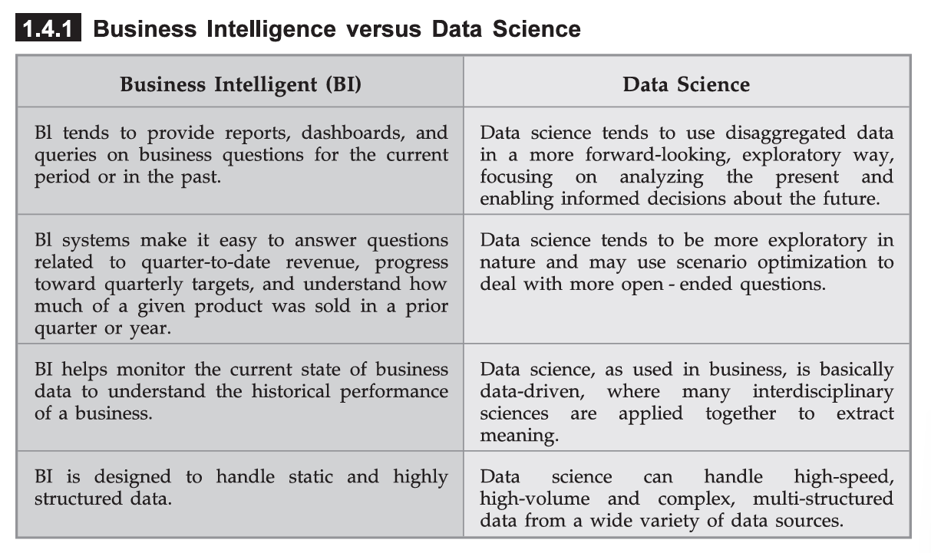

Sources of Big Data

Sources of Big Data?

Big data refers to the huge amounts of data created every second from various sources like social media, smart devices, and online transactions. This data is so large and complex that regular tools can’t handle it. Big data is essential because it helps businesses make better decisions, researchers find solutions, and governments improve services.

| **Data Source** | **Description** | **Examples** |
| --- | --- | --- |
| **Social Media** | User-generated content from platforms and interactions. | Twitter hashtags, Instagram trends, Facebook ad engagement. |
| **Sensors** | IoT devices and sensors that capture real-time environmental or machine data. | Smart thermostats, factory equipment logs, weather monitors. |
| **Transactions** | Data from financial and retail activities, e-commerce, or banking. | Bank transactions, purchase histories, POS data. |
| **Healthcare** | Information from medical records, diagnostics, and wearable devices. | Electronic health records, MRI scans, fitness tracker data. |
| **Government Data** | Public datasets from national agencies and systems. | Census statistics, traffic data, meteorological information. |
| **Media and Entertainment** | Data related to user engagement with digital content and platforms. | Netflix viewing habits, YouTube watch time, Spotify song plays. |
| **Industrial Data** | Information from manufacturing processes, robotics, and supply chains. | Assembly line performance, logistics tracking, robotic sensors. |
| **Scientific Research** | Data collected for studies in fields like astronomy, genomics, and climate science. | Satellite images, DNA sequencing results, global temperature data. |

Main Considerations in Processing Big Data

### **Main Considerations in Processing Big Data**

To effectively process Big Data, several key considerations must be addressed:

### **1. Scalability**

* Systems must scale **horizontally** to handle growing data volumes.
* Distributed computing frameworks like **Hadoop** and **Apache Spark** are commonly used.

### **2. Storage**

* Choose appropriate storage systems:  
  + **HDFS** for batch processing.
  + **NoSQL databases** (e.g., Cassandra, MongoDB) for flexibility.
  + **Cloud storage** (e.g., AWS S3) for cost-effective, scalable solutions.

### **3. Processing Speed**

* Use **parallel processing** and **in-memory computation** to reduce processing time.
* Tools like **Apache Spark** are optimized for speed over large datasets.

### **4. Data Quality**

* Ensure data is **clean, consistent, and reliable** before analysis.
* Involves **data cleansing**, validation, and preprocessing.

### **5. Security and Privacy**

* Protect sensitive data through **encryption**, **access control**, and **compliance** (e.g., GDPR).
* Data anonymization may be required in some applications.

### **6. Integration**

* Ability to integrate data from **multiple sources** (structured, unstructured, real-time).
* Use APIs, connectors, or ETL tools for smooth data flow.

### **7. Cost Efficiency**

* Optimize for **compute and storage costs**, especially in cloud environments.
* Choose tools that balance performance and budget.

### **8. Fault Tolerance and Reliability**

* Distributed systems should be able to **handle failures gracefully**.
* Use **replication**, **checkpointing**, and **redundancy** to ensure data safety.

Explain big data analytics architecture

Explain big data analytics architecture

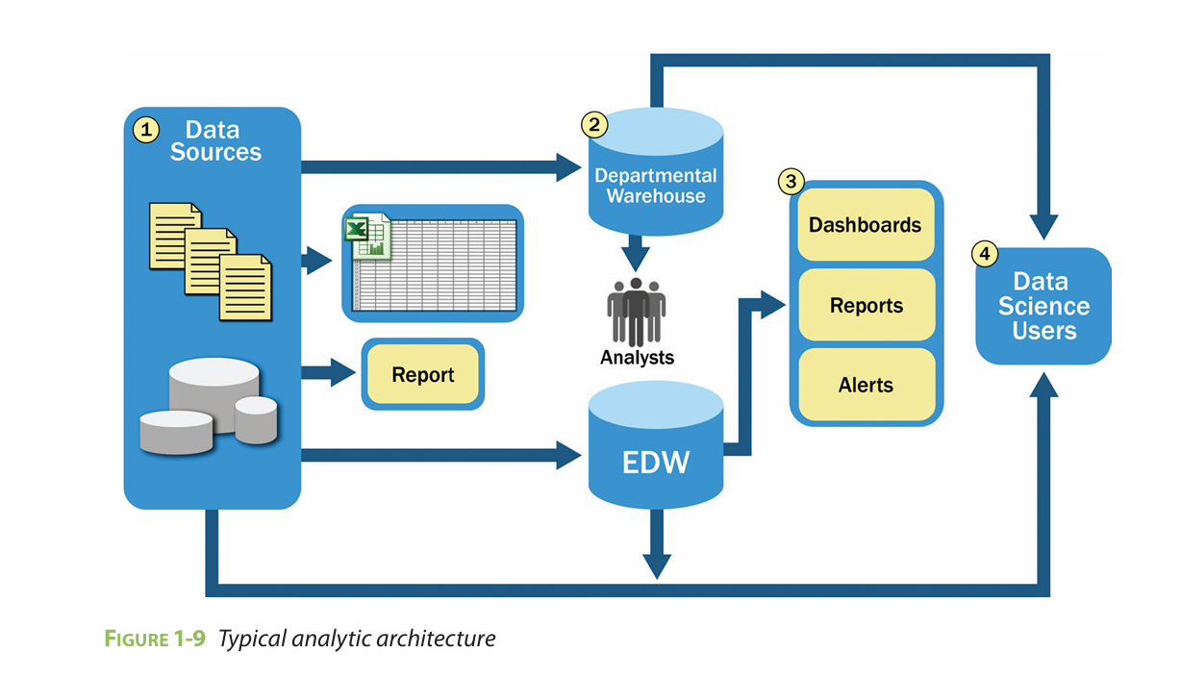

Figure 1-9 shows a typical data architecture and several of the challenges it presents to data scientists and others trying to do advanced analytics.

1. For data sources to be loaded into the data warehouse, data needs to be **well understood, structured, and normalized** with the appropriate data type definitions. Although this kind of **centralization** enables security, backup, and failover of highly critical data, it also means that data typically must **go through significant preprocessing** and checkpoints before it can enter this sort of controlled environment, which does not lend itself to data exploration and iterative analytics.
2. Due to the strict control in EDW (Enterprise Data Warehouse), departments often create **local data marts** for flexible analysis.
3. These local systems are not as controlled, leading to **isolation**, lack of **synchronization**, and potential **data inconsistency**. But they in-depth analysis.
4. Once data is in the warehouse, it is used by Business Intelligence (BI) applications for generating reports and insights. These processes are **operationally critical** and heavily depend on the data warehouse for consistent data feeds.
5. At the end of the process, analysts get data that they can use for further analysis. Since they usually can't run heavy or custom analysis directly on the main databases, they create **data copies (extracts)** from the data warehouse and work with them separately using tools like **R** on their own computers.
6. Often, these tools can only handle small portions of the data (samples) instead of the entire dataset because of limited memory.
7. The analysis results usually stay **isolated**, and insights are not fed back into the central data warehouse, leading to a **disconnect** between insights and the main data repository.

Data Analytics Life Cycle

Data Analytics Life Cycle

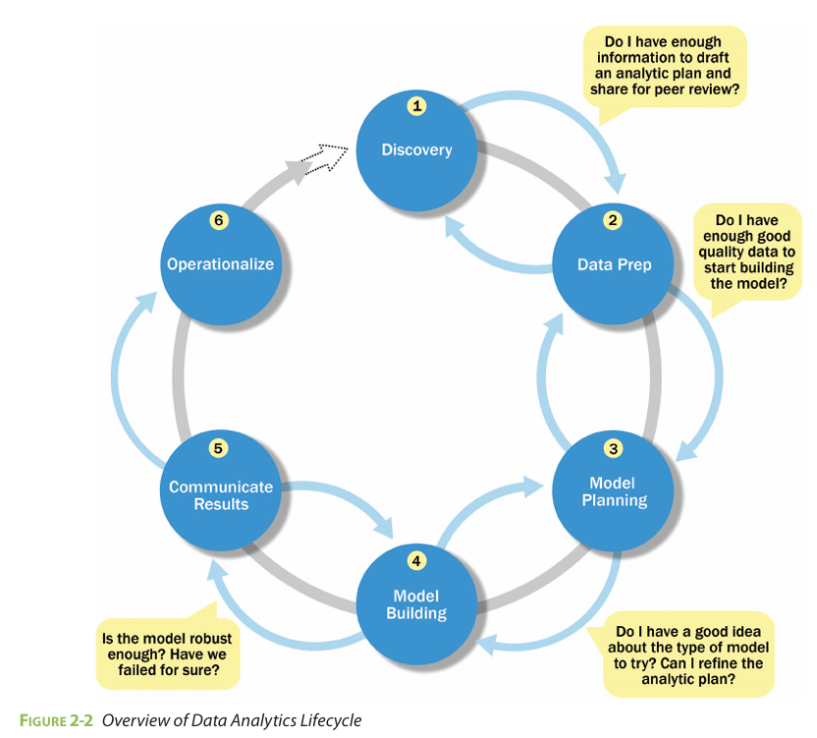

The Data Analytics Lifecycle defines analytics process best practices spanning discovery to project completion.

**Phase 1—Discovery**:

1. In Phase 1, the team learns the business domain, including relevant history such as whether the organization or business unit has attempted similar projects in the past from which they can learn.
2. The team assesses the resources available to support the project in terms of people, technology, time, and data.
3. Important activities in this phase include framing the business problem as an analytics challenge that can be addressed in subsequent phases and formulating initial hypotheses (IHs) to test and begin learning the data.

**Phase 2—Data preparation**:

1. Phase 2 requires the presence of an analytic sandbox, in which the team can work with data and perform analytics for the duration of the project.
2. The team needs to execute extract, load, and transform (ELT) or extract, transform and load (ETL) to get data into the sandbox. The ELT and ETL are sometimes abbreviated as ETLT.
3. Data should be transformed in the ETLT process so the team can work with it and analyze it. In this phase, the team also needs to familiarize itself with the data thoroughly and take steps to condition the data

**Phase 3—Model planning**:

1. Phase 3 is model planning, where the team determines the methods, techniques, and workflow it intends to follow for the subsequent model building phase.
2. The team explores the data to learn about the relationships between variables and subsequently selects key variables and the most suitable models.
3. Tools: R, Python, SQL, SAS

**Phase 4—Model building**:

1. In Phase 4, the team develops datasets for testing, training, and production purposes.
2. In addition, in this phase the team builds and executes models based on the work done in the model planning phase.
3. The team also considers whether its existing tools will suffice for running the models, or if it will need a more robust environment for executing models and workflows (for example, fast hardware and parallel processing, if applicable).
4. Tools: R, Python, Hadoop, Apache Spark, Matlab, Rapid Miner

**Phase 5—Communicate results**:

1. In Phase 5, the team, in collaboration with major stakeholders, determines if the results of the project are a success or a failure based on the criteria developed in Phase 1.
2. The team should identify key findings, quantify the business value, and develop a narrative to summarize and convey findings to stakeholders.

**Phase 6—Operationalize**:

1. In Phase 6, the team delivers final reports, briefings, code, and technical documents.
2. In addition, the team may run a pilot project to implement the models in a production environment.

What is Discovery Phase

What is Discovery Phase? Explain with example

1. The first phase of the Data Analytics Lifecycle involves discovery. In this phase, the data science team must learn and investigate the problem, develop context and understanding, and learn about the data sources needed and available for the project. In addition, the team formulates initial hypotheses that can later be tested with data.
2. **Learning the Business Domain**: Understanding the domain area of the problem is essential. In many cases, data scientists will have deep computational and quantitative knowledge that can be broadly applied across many disciplines. Others in this area may have deep knowledge of a domain area, coupled with quantitative expertise.
3. **Resources**: As part of the discovery phase, the team needs to assess the resources available to support the project. After taking inventory of the tools, technology, data, and people, consider if the team has sufficient resources to succeed on this project, or if additional resources are needed
4. **Framing the Problem**: Framing the problem well is critical to the success of the project. Framing is the process of stating the analytics problem to be solved. At this point, it is a best practice to write down the problem statement and share it with the key stakeholders.
5. **Identifying Key Stakeholders**: Another important step is to identify the key stakeholders and their interests in the project.
6. **Developing Initial Hypotheses**: Developing a set of IHs is a key facet of the discovery phase. This step involves forming ideas that the team can test with data.

**Example:** A retail company wants to analyze why its online sales dropped in the last quarter.

**Learning the Business Domain**:

1. Understand the retail industry, typical online sales patterns, and seasonal trends.
2. The team collaborates with the marketing and sales departments to understand potential reasons for the decline.

**Assessing Resources**:

1. Identify data sources like website traffic logs, sales data, customer feedback, and social media mentions.
2. Check if the team has access to Google Analytics data, CRM systems, and social media monitoring tools.

**Framing the Problem**:

1. Formulate the problem as:

"Identify the reasons for the drop in online sales during the last quarter and suggest strategies to improve sales in the next quarter."

1. Share the problem statement with marketing managers and sales executives.

**Identifying Key Stakeholders**:

1. Marketing, sales, e-commerce, and customer support teams are identified as stakeholders.
2. Ensure their insights and requirements are considered.

**Developing Initial Hypotheses**:

Hypotheses might include:

1. "Sales dropped due to an ineffective ad campaign."
2. "Website performance issues led to fewer completed purchases."
3. "Competitor promotions attracted customers away."

Data Preparation Phase

What is data preparation phase in Data Analytics Lifecycle? What is the Analytics Sandbox and ETLT process in this phase

1. The second phase of the Data Analytics Lifecycle involves data preparation, which includes the steps to explore, preprocess, and condition data prior to modeling and analysis.
2. In this phase, the team needs to create a robust environment in which it can explore the data that is separate from a production environment.
3. Usually, this is done by preparing an analytics sandbox. The Analytics Sandbox is a secure, scalable, and isolated environment where data scientists can explore and analyze data without affecting the main data systems.
4. **Preparing the Analytic Sandbox**: The first subphase of data preparation requires the team to obtain an analytic sandbox (also commonly referred to as a workspace), in which the team can explore the data without interfering with live production databases. Consider an example in which the team needs to work with a company’s financial data. The team should access a copy of the financial data from the analytic sandbox rather than interacting with the production version of the organization’s main database, because that will be tightly controlled and needed for financial reporting.
5. To get the data into the sandbox, the team needs to perform ETLT, by a combination of extracting, transforming, and loading data into the sandbox.
6. **Performing ETLT**:

In ETL, users perform extract, transform, load processes to extract data from a datastore, perform data transformations, and load the data back into the datastore.

However, the analytic sandbox approach differs slightly; it advocates extract, load, and then transform.

The reason for this approach is that there is significant value in preserving the raw data and including it in the sandbox before any transformations take place.

For instance, consider an analysis for fraud detection on credit card usage. Many times, outliers in this data population can represent higher-risk transactions that may be indicative of fraudulent credit card activity. Using ETL, these outliers may be inadvertently filtered out or transformed and cleaned before being loaded into the datastore.

1. The team may want clean data and aggregated data and may need to keep a copy of the original data to compare against or look for hidden patterns that may have existed in the data before the cleaning stage. This process can be summarized as ETLT to reflect the fact that a team may choose to perform ETL in one case and ELT in another.
2. Once the data is in the sandbox, the team needs to learn about the data and become familiar with it. Understanding the data in detail is critical to the success of the project.
3. The team also must decide how to condition and transform data to get it into a format to facilitate subsequent analysis. The team may perform data visualizations to help team members understand the data, including its trends, outliers, and relationships among data variables.

Short Note on ETL

Short Note on ETL (Extract, Transform and Load)

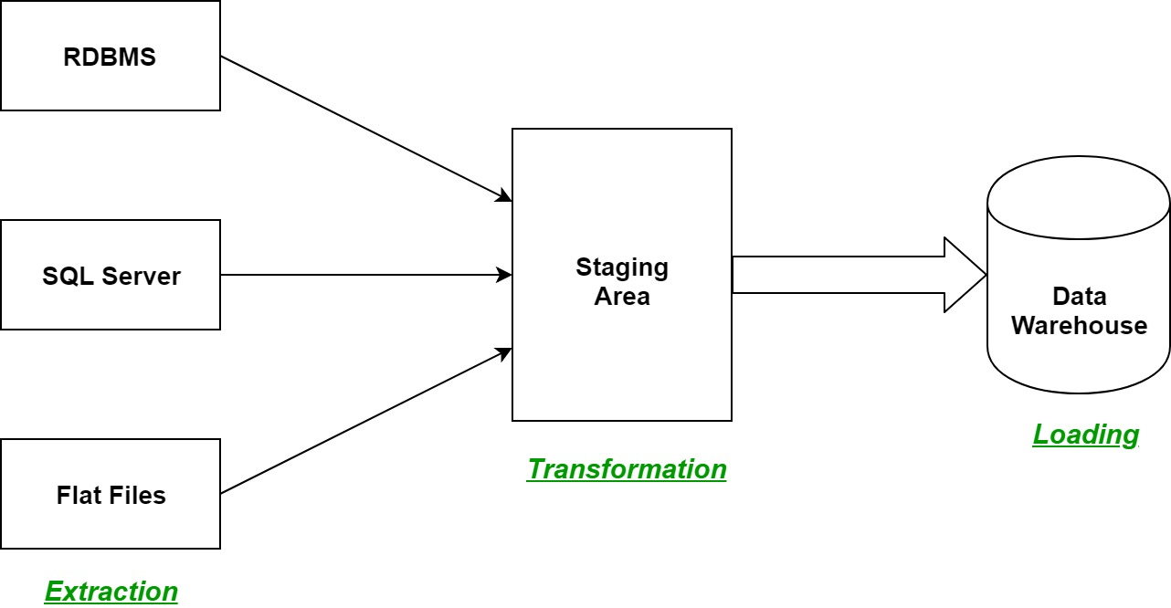

ETL stands for Extract, Transform, Load, which is a process used to collect data from various sources, clean and transform it, and load it into a target system (like a data warehouse).

**Extract**: Data is gathered from multiple sources such as databases, files, or APIs. The goal is to consolidate data into a single format.

**Transform**: The extracted data is cleaned, formatted, and transformed to ensure consistency. This may include data normalization, filtering, aggregation, or applying business rules.

**Load**: The transformed data is loaded into a data warehouse, data lake, or another centralized repository for analysis and reporting.

Model Planning Phase

Model Planning Phase and activities performed in this phase

1. In Phase 3, the data science team identifies candidate models to apply to the data for clustering, classifying, or finding relationships in the data depending on the goal of the project
2. It is during this phase that the team refers to the hypotheses developed in Phase 1, when they first became acquainted with the data and understanding the business problems or domain area. These hypotheses help the team frame the analytics to execute in Phase 4 and select the right methods to achieve its objectives.

Some of the activities to consider in this phase include the following:

1. Assess the structure of the datasets: The structure of the datasets is one factor that dictates the tools and analytical techniques for the next phase. Depending on whether the team plans to analyze textual data or transactional data, for example, different tools and approaches are required.
2. Ensure that the analytical techniques enable the team to meet the business objectives and accept or reject the working hypotheses.
3. Determine if the situation warrants a single model or a series of techniques as part of a larger analytic workflow.
4. In addition, it is useful to research and understand how other analysts generally approach a specific kind of problem

Model Selection for Data Analytics

Model Selection for Data Analytics

1. Model selection is a subphase of Model Planning phase of Data Anaytics Lifecycle.
2. In this subphase, the team’s main goal is to choose an analytical technique, or a short list of candidate techniques, based on the end goal of the project.
3. The chosen model should directly address the problem statement and the project’s objectives.
4. When reviewing this list of types of potential models, the team can reduce down the list to several viable models to try to address a given problem
5. An additional consideration in this area is determining if the team will be using techniques that are best suited for structured data, unstructured data, or a hybrid approach
6. Lastly, the team should take care to identify and document the modeling assumptions it is making as it chooses and constructs preliminary models.
7. The team can move to the model building phase once it has a good idea about the type of model to try and the team has gained enough knowledge to refine the analytics plan.

Model Building Phase

Explain Model Building Phase

Model Building In Data Analytics

1. Model building is an essential part of data analytics and is used to extract insights and knowledge from the data to make business decisions and strategies.
2. In this phase of the project data science team needs to develop data sets for training, testing, and production purposes. These data sets enable data scientists to develop an analytical method and train it while holding aside some of the data for testing the model.
3. Model building in data analytics is aimed at achieving not only high accuracy on the training data but also the ability to generalize and perform well on new, unseen data.
4. Therefore, the focus is on creating a model that can capture the underlying patterns and relationships in the data, rather than simply memorizing the training data.
5. Scaling is is also performed before feeding data to a model. It ensures that features with different ranges do not dominate the model, improving accuracy and performance.
6. Model Selection: Choose the appropriate algorithm based on the problem type (regression, classification, clustering, etc.).
7. Training the Model: Use the training dataset to fit the model, allowing it to learn patterns and relationships.
8. Hyperparameter Tuning: Adjust parameters that control the model's behavior (like learning rate or tree depth) to optimize performance.
9. Validation: Test the model using a validation dataset to assess its accuracy and generalizability.
10. Evaluation Metrics: Calculate metrics (like accuracy, precision, recall) to measure model performance.
11. Free or open-source tools - R and PL/R, Octave, WEKA.

Commercial tools - Matlab and STASTICA.

### Example of Model Building

**Problem:** Predict house prices based on features like number of rooms, size, and location.

1. **Data Collection:** A dataset of 1,000 houses with features (rooms, size, location) and target (price).
2. **Preprocessing:**
   * Convert categorical data like location to numerical (using one-hot encoding).
   * Normalize features like size and rooms.
   * Split data (e.g., 80% train, 20% test).
3. **Model Selection:** Use **Linear Regression** as it’s a regression problem.
4. **Training:** Feed training data to the linear regression model.
5. **Evaluation:** Use test data and calculate **Mean Squared Error (MSE)** or **R² Score** to assess performance.
6. **Outcome:** A trained model that can predict house prices for new data.

Common Tools for the Model Building Phase

Common Tools for the Model Building Phase

There are many tools available to assist in this phase, focused primarily on statistical analysis or data mining software. Common tools in this space include, but are not limited to, the following:

**Commercial Tools**:

1. **SAS Enterprise Miner**: allows users to run predictive and descriptive models based on large volumes of data from across the enterprise. It interoperates with other large data stores, has many partnerships, and is built for enterprise-level computing and analytics.
2. **Matlab**: provides a high-level language for performing a variety of data analytics, algorithms, and data exploration.
3. **Alpine Miner**: provides a GUI front end for users to develop analytic workflows and interact with Big Data tools and platforms on the back end.

**Free or Open Source tools**:

1. **R and PL/R**: R was described earlier in the model planning phase, and PL/R is a procedural language for PostgreSQL with R. Using this approach means that R commands can be executed in database. This technique provides higher performance and is more scalable than running R in memory.
2. **Python**: is a programming language that provides toolkits for machine learning and analysis, such as scikit-learn, numpy, scipy, pandas, and related data visualization using matplotlib.
3. **SQL in-database** implementations, such as **MADlib**: provide an alterative to in-memory desktop analytical tools. MADlib provides an open-source machine learning library of algorithms that can be executed in-database, for PostgreSQL or Greenplum.

Key Stakeholders

List out different stakeholders of an analytics project. What they usually expect at the conclusion (key outputs) of a project?

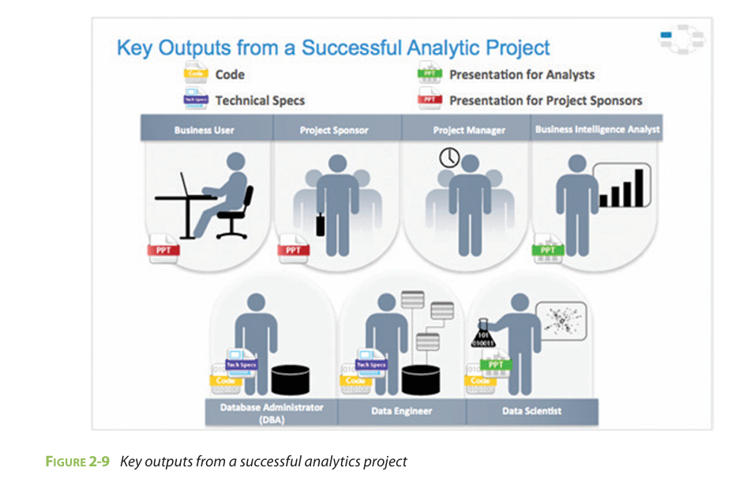

An analytics project involves multiple stakeholders, each having a specific role and unique expectations at the conclusion of the project. Understanding their roles and what they typically expect helps ensure the project's success and alignment with organizational goals.

1. **Business User**: Typically a manager, executive, or decision-maker who uses analytics insights to make business decisions.

Expectations:

1. **Understanding of Benefits**: They want to see how the analytics outcomes will positively impact the business.
2. **Implications of Findings**: They look for practical recommendations derived from the data analysis to improve business processes or outcomes.
3. **Project Sponsor**: The person who finances or champions the project within the organization.

Expectations:

1. **Business Impact**: How the project will benefit the company in terms of growth or efficiency.
2. **Risk and ROI Assessment**: The sponsor needs to evaluate the return on investment (ROI) and any potential risks involved.
3. **Project Promotion**: They look for ways to promote the project internally and externally, showcasing its success and potential
4. **Project Manager**: Responsible for overseeing the project timeline, budget, and overall execution.

Expectations:

1. **Completion on Time and Budget**: The project manager checks if the project was delivered as planned.
2. **Goal Fulfillment**: They assess how well the project's objectives were met.
3. **Documentation and Reporting**: A summary of project outcomes and any challenges faced.
4. **Business Intelligence (BI) Analyst**: Develops reports, dashboards, and visual analytics for business insights.

Expectations:

1. **Impact on Reports**: They want to know if the existing dashboards or reports need modification based on new data or insights.
2. **Improved Visualization**: Enhanced data presentation that accurately reflects the findings.
3. **Data Engineer and Database Administrator (DBA)**: Responsible for data processing, storage, and database management.

Expectations:

1. **Code Sharing**: They expect to receive the final code or algorithms from the project.
2. **Technical Documentation**: A clear guide on how to integrate and implement the model within existing systems.
3. **Data Pipelines**: Details on how to maintain the data flow for continuous analysis.
4. **Data Scientist**: Analyzes data, builds models, and interprets insights.

Expectations:

1. **Model Explanation**: Clearly explain the model's workings, accuracy, and relevance.
2. **Code Sharing**: Share the code and logic used in model development.
3. **Peer Collaboration**: Discuss the model with fellow data scientists and managers to validate and optimize it.